**LEBANESE AMERICAN UNIVERSITY**

**USAID – HIGHER EDUCATION SCHOLARSHIP PROGRAM**

**HES - Volunteering Program Verification Form**

This form is to be used to document volunteering hours. If a student volunteers for multiple organizations, a separate form must be used for each organization. **This form must be turned in by the 28th of each month, the latest.**

I certify that the scholar Malak Mershad completed a total of 5 hours of service at InnovaThrive.

The hours were completed hours as per the below:

Hours # 5 (date) _4/11 – 8/11_ (initials of supervisor) __A.K.___

Hours # 0 (date) _11/11 – 15/11_ (initials of supervisor) __A.K.___

Hours # 0 date) _18/11 – 22/11 (initials of supervisor) __A.K.___

Hours # 0 date) _25/11 - 29/11 (initials of supervisor) __A.K.___

Brief description of the activities the scholar performed or participated in:

I requested a task that is related to the field of business so I can expand my practical knowledge in my major. The task was to study consumers consumption and choices. I was asked to search the factors that affect ones' consumption behaviors and the methods companies can implement to discover the emerging markets and meet the changing needs of the societies. Besides, I was asked to showcase real-case scenarios of products that boomed due to social media trends and products that failed due to the failing strategies of the company. It was a very nice opportunity to know more about a crucial aspect of a firm who are consumers. Once the firm identifies its consumers and their needs, it can achieve profit and ensure long-term loyalty to its products.

Written feedback about the scholar’s performance:

Malak has demonstrated strong analytical and practical skills. She has shown an ability to effectively connect theoretical knowledge to real-world applications, particularly in consumer behavior research.

Please rate the overall performance of the scholar at your organization:

|  |  |  |  |
| --- | --- | --- | --- |
|  | Mastery (5) | Proficient (3) | Emerging (1) |
| **Problem solver** | X |  |  |
| **Engaged & Committed** | X |  |  |
| **Open-minded & multicultural** | X |  |  |

Signature

& stamp

__________________________

_

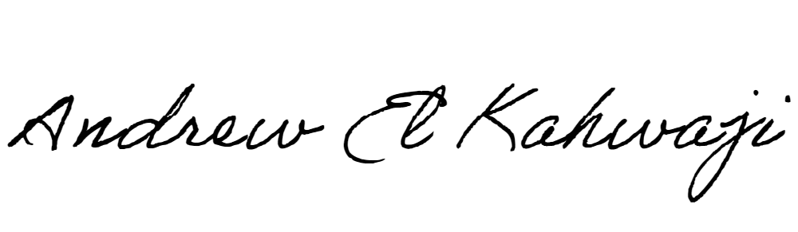

Printed Name _Andrew El Kahwaji_

Date __26/11/2024___

Email __andrew.lifesculptor.coo@gmail.com __

Phone __+961 71 914 378__

**LEBANESE AMERICAN UNIVERSITY**

**USAID – HIGHER EDUCATION SCHOLARSHIP PROGRAM**

